<https://www.ncbi.nlm.nih.gov/pmc/articles/PMC10203444/>

<https://www.mdpi.com/2073-4395/12/1/197>

<https://www.mdpi.com/1424-8220/20/21/6271>

<https://www.mdpi.com/1999-4907/13/12/2062>

<https://www.mdpi.com/2072-4292/13/12/2337>

<https://www.mdpi.com/2076-3417/9/22/4799>

<https://link.springer.com/article/10.1007/s00271-022-00775-1>

<https://www.sciencedirect.com/science/article/pii/S0013935122006053>

<https://doi.org/10.1016/j.ecoinf.2024.102697>

[10.1109/ICIS46139.2019.8940265](https://doi.org/10.1109/ICIS46139.2019.8940265)

[10.48550/arXiv.2211.14387](http://dx.doi.org/10.48550/arXiv.2211.14387)

**Study on Root zone temp:**

<https://kryzen.com/optimizing-root-zone-temperature-for-hydroponic-crops/>

The optimal root zone temperature for most hydroponic crops falls within **18°C to 22°C** (64°F to 72°F)

<https://www.canna-uk.com/articles/root-zone-temperature-and-plant-health>

The part of the plant below the surface is called the root zone and is not able to regulate its temperature at all. The **temperature range is therefore smaller and the roots need to stay cooler.**

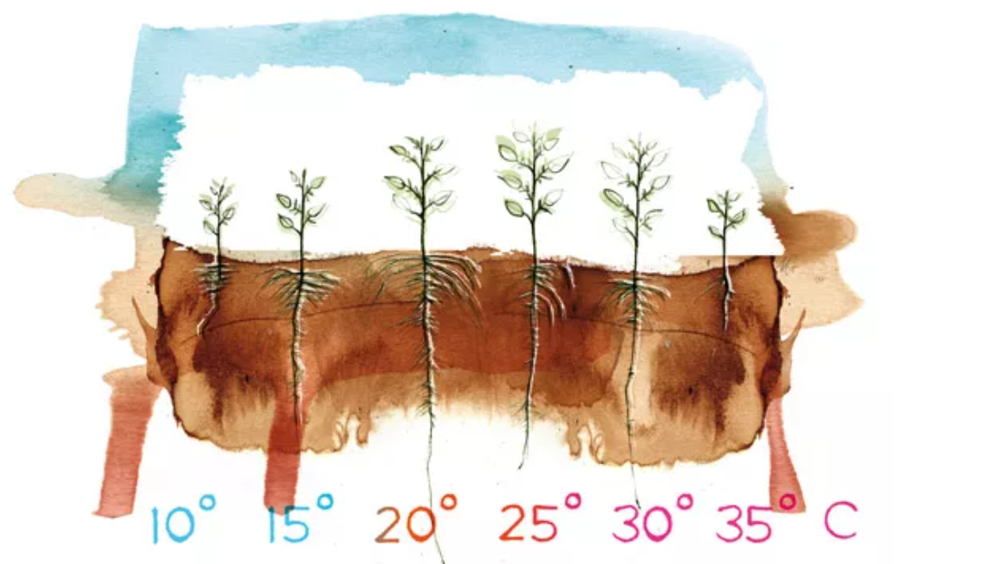

<https://pubmed.ncbi.nlm.nih.gov/35169910/>

Two air temperature treatments (30/25 °C and 25/20 °C day/night) and five RZT treatments (**15, 20, 25, 30, 35 °C**) were applied to lettuce plants.

Maximum growth occurred at **30/25 °C** air temperature, with an **optimal RZT of 30 °C**. At 25/20 °C air temperature, the optimal RZT was 25 °C.

<https://academic.oup.com/aob/article/132/3/455/7265388#427417175>

Lettuce (Lactuca sativa, red leaf cultivar ‘Red Fire’) was grown hydroponically under three root zone temperature (RZT) treatments **(15, 25, or 35 °C)** for 13 days.

After a certain growth period, the plants are harvested, and their parts (shoots, which include leaves and stems, and roots) are dried in an oven. This removes all water content. Once dried, the shoots and roots are weighed separately. The weight represents the *dry biomass*, which is essentially the solid, structural material in the **plant—like cellulose, proteins, and other compounds.**

**Optimal Growth: 25 °C RZT**

* 25 °C RZT: Achieved maximum shoot and root dry weight.
* 35 °C RZT: Decreased overall growth but increased pigment content.
* 15 °C RZT: Resulted in lower pigment content and less optimal growth compared to 25 °C.

<https://www.frontiersin.org/journals/plant-science/articles/10.3389/fpls.2024.1352331/full#f2>

RZT -> 3% + air temperature

At 17°C air temperature, the RZT increase led to 23% more shoot dry mass and 30% more root dry mass.

At 22°C air temperature, shoot and root dry masses increased by 31% and 24%, respectively.

**At 27°C air temperature, shoot and root dry masses were 18% and 22% greater.**

At 30°C air temperature, shoot and root dry masses were 14% and 19% greater.

<https://eos.com/blog/soil-temperature/#for-seeding>

<https://www.sciencedirect.com/topics/agricultural-and-biological-sciences/root-zone-temperature#:~:text=It%20may%20be%20concluded%20that,temperature%20fluctuations%20exceeding%20this%20range>.

